|  |
| --- |
| ACTS |
| Advanced Low-level Controller – ALC 3.0 |
| Install Manual |
|  |
| **[键入作者姓名]** |
| **2019/9/26** |

|  |
| --- |
| ACTS Technologies Inc. |

Contents

1 Overview 3

1 Operating System 3

2 Download and install NI-DAQmx driver 3

3 Supply your Hardware info 4

4 Copy and Install 4

5 Update new version and Help documents 4

# 1 Overview

The purpose of this document is to familiarize the user with the operation of the ACTS Advanced Low-level Controller – ALC 3.0.

# 1 Operating System

Windows 10.

# 2 Download and install NI-DAQmx driver

NI-DAQmx provides support for customers using NI data acquisition and signal conditioning devices.

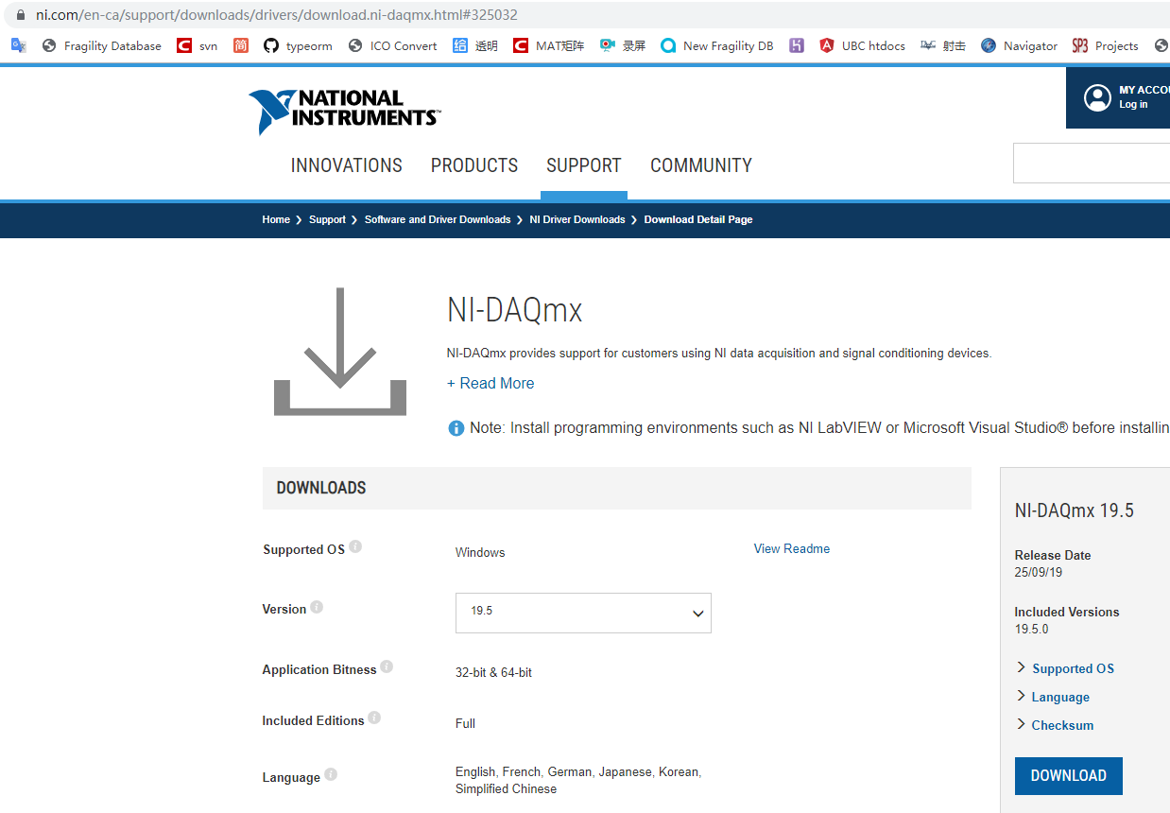

# 3 Supply your Hardware info

At command line window, enter “ipconfig /all”, and copy output info to ACTS.

At c:\>, enter “dir /w”, and copy output info to ACTS.

# 4 Copy and Install

Copy all software to c:\acts.

# 5 Update new version and Help documents

https://github.com/MingJing2015/ACTS-manual-and-video.git

If you have any questions regarding this manual, please contact ACTS.